**ComfyUI use practice**

**1. The basic workflow of text-to-image**

Generate work name: JOKER's leisure moment

Work display:

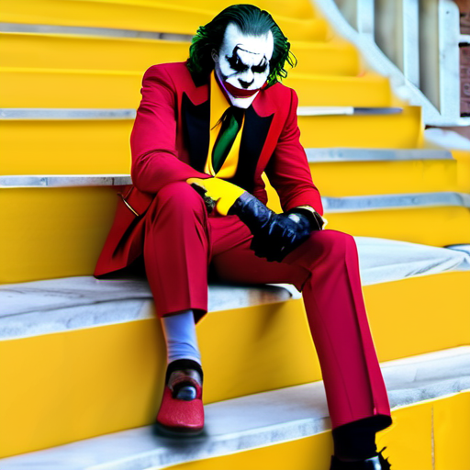 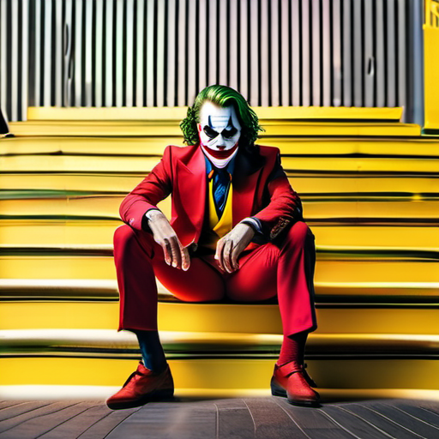

Workflow screenshots:

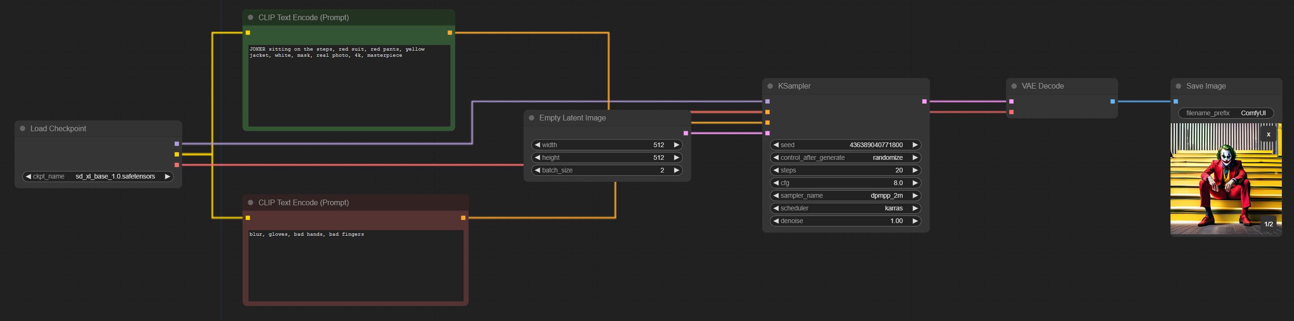

Workflow and picture inspiration description:

This is an attempt to build a basic workflow of text-to-image, select nodes and build a workflow according to the working principle of the STABLE Diffusion model, and beautify the workflow by combining the knowledge from the classroom, such as modifying the color, shape of the line, and grouping, etc. The workflow is inspired by a movie called JOKER. The inspiration for the picture came from a movie called JOKER that I watched recently. I really liked the crazy image of the male protagonist, so I wanted to create a picture related to him. Unfortunately, because the model itself can't handle the hand details well, the final generated picture will always have problems in the hand.

**2. The basic workflow of image-to-image**

Name: JOKER's leisure moment - refined high-definition version

Work to show:

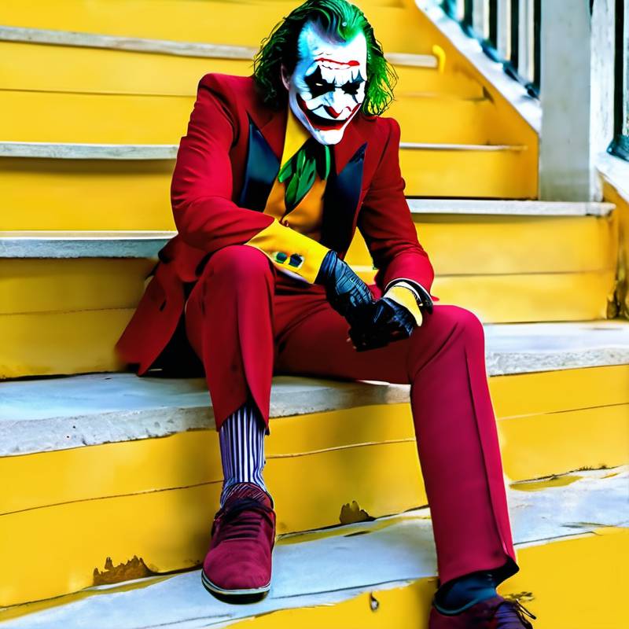

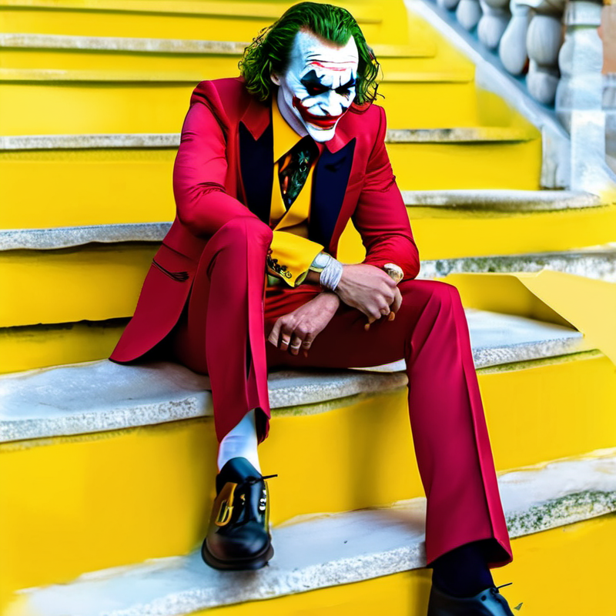

Workflow screenshots:

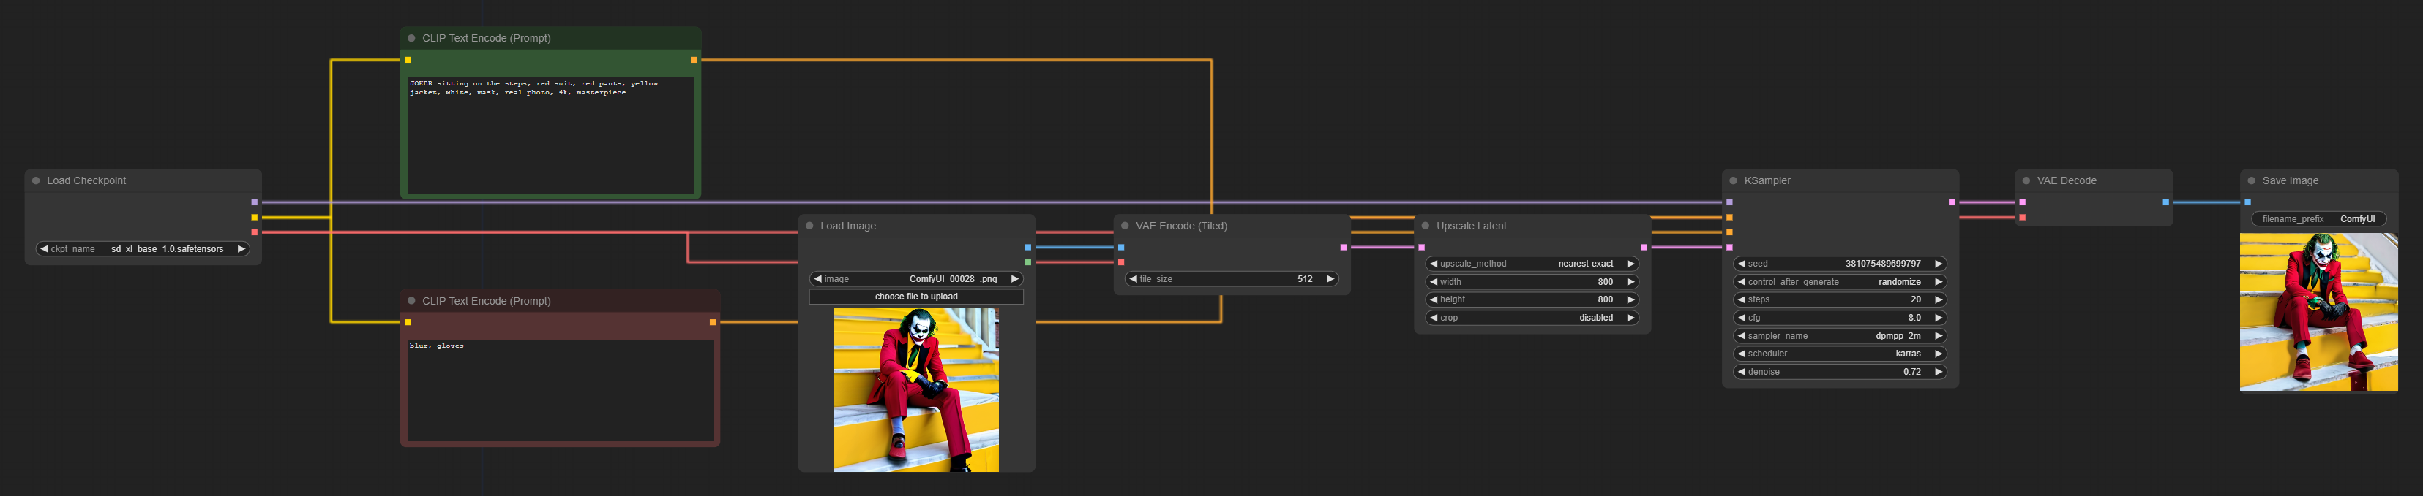

Workflow and picture inspiration description:

This is an attempt to build a basic workflow of graph-generated graphs, selecting nodes and building a workflow according to the working principle of the stable diffusion model, and combining the knowledge gained from the classroom to beautify the workflow, as well as further exploring the role of each parameter in the KSampler. The image follows the first generated image, which is imported and noised as the base image, and the size of the generated image is changed by modifying the latent space size. In order to make the redrawn image still similar to this one, I reduced the denoise parameter to 0.72 (0.5 is better for the characters but the background will be blurred or distorted), and finally realized the generation of a larger and clearer image similar to the original one.

**3. Image-to-image, tarot card style workflow**

Generate work name: JOKER-THE FOOL

Work show:

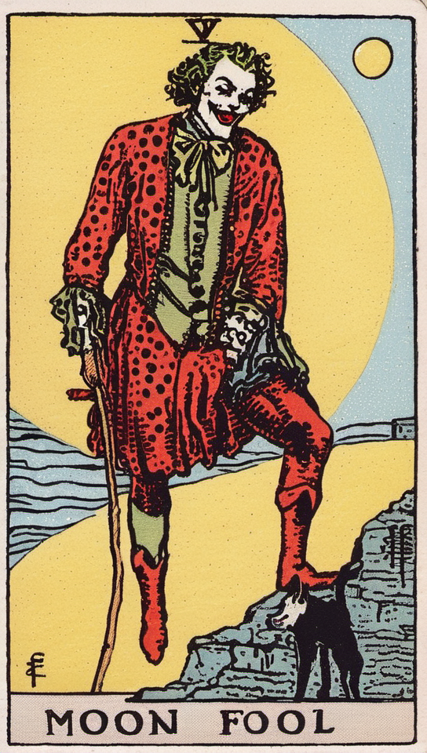 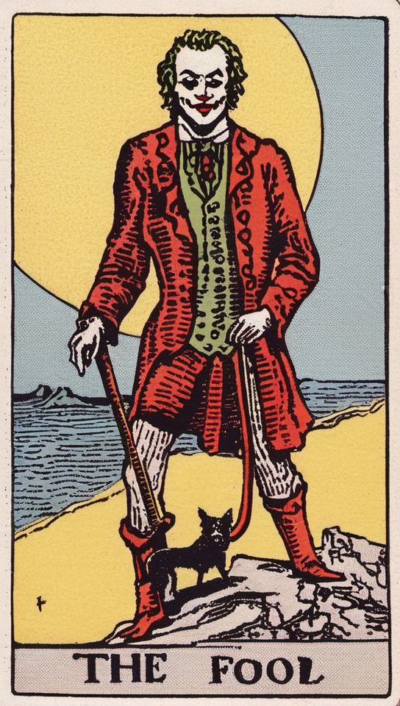

Workflow screenshots:

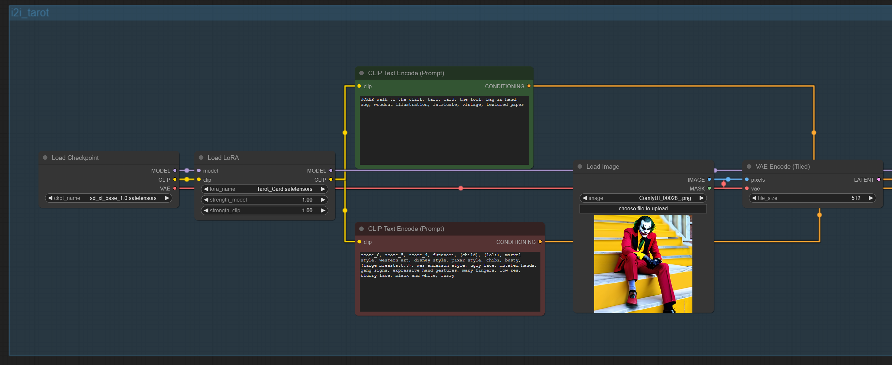

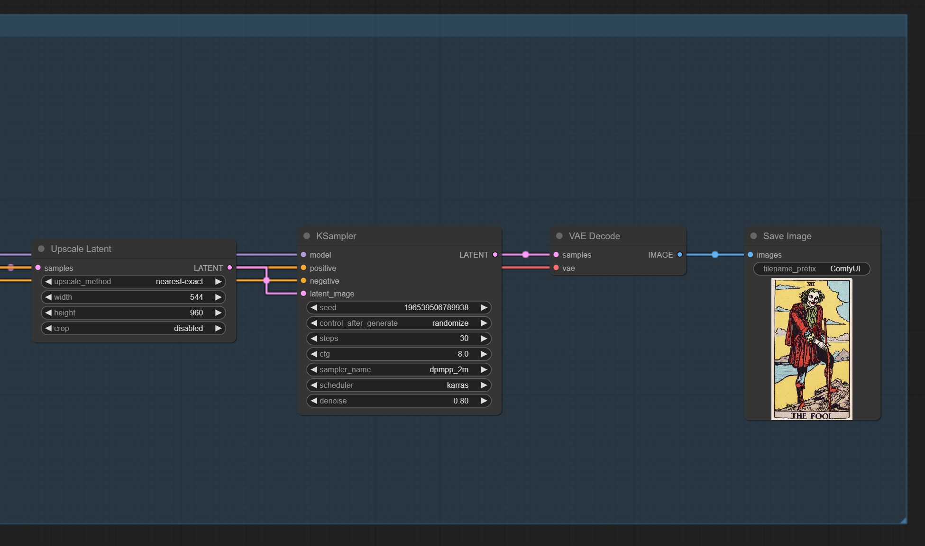

Workflow and image inspiration description:

This is an attempt to build an advanced workflow of graph-generated graphs, adding LoRA model to the basic workflow to achieve the effect of changing the picture style. The base image is still used as above, this time I want to change the image style to Tarot. Due to the semantic similarity between JOKER and FOOL (ironic on the surface but with a deeper meaning), I linked them together to create a new Fool deck. I kept the classic intentions of the Fool's cards in the text compiler: the bag, the cliff, the dog, and copied the negative cues provided by the author of the original LoRA model, and ended up with a more satisfactory result.